Historicity, Strengths, and Weaknesses of Allan Variances and Their General Applications
By
David W. Allan
President, Allan’s TIME; Fountain Green, Utah 84632-0066;
e-mail: david@allanstime.com
Web sites: www.allanstime.com www.ItsAboutTimeBook.com

KEYWORDS: Allan variances, Time series analysis, Atomic clocks, Precision analysis, Non-stationary processes
SUMMARY: Over the past 50 years variances have been developed for characterizing the instabilities in precision clocks and oscillators. These instabilities are often modeled by non-stationary processes, and these variances have been shown to be well-behaved and to be unbiased, optimum descriptors of these processes. The time-domain and frequency-domain relationships are shown along with the strengths and weaknesses of these characterization metrics. These variances are also shown to be useful elsewhere.
INTRODUCTION
Nature gives us many non-stationary and chaotic processes. If we can properly characterize these processes, then we can use optimal procedures for estimation, smoothing, and prediction. During the 1960s through the 1980s, the Allan variance, the modified Allan variance, and the Time variance were developed to this end for the timing and the telecommunication communities. Since that time, useful refining techniques have been developed. This activity has been a learning endeavor, and the strengths and weaknesses of these variances will be enumerated. The applicability of these variances has been recognized in other areas of metrology as well because the above processes are ubiquitous. Knowing the strengths and weaknesses is important not only in time and frequency but so that these variances may be properly utilized in other application areas, e.g. navigation.
Prior to the 1960s and before atomic clocks were commercially available, quartz-crystal oscillators were used for timekeeping. The greatest long-term-frequency instabilities in these oscillators were their frequency drifts. Also, it was commonly recognized that their long-term performance seemed to be modeled by what is commonly called flicker-noise frequency modulation (FM), which model is a non-stationary process because this noise has an FM spectral-density proportional to 1/f, where f is the Fourier frequency. In integrating this kind of noise to determine the classical variance, one observes that the integral is non-convergent.
In 1964, James A. Barnes developed a generalized auto-correlation function that was well behaved for flicker noise. I was fortunate to have him for my mentor at the National Bureau of Standards (NBS) in Boulder, Colorado. That same year the IEEE and NASA held a special conference at NASA, Goddard, in Beltsville, Maryland, addressing the problem of how to characterize clocks with these non-stationary behaviors. Jim and I presented a paper at this conference, and it was well received. His work was the basis for his Ph.D. thesis, and it also gave me critical information that I needed for my master’s thesis. We both finished our theses the following year. In addition to Jim’s work, I relied heavily on the book that Jim had shown me by Sir James Michael Lighthill, Fourier Analysis and Generalized Functions. Along with Jim’s work, this book was invaluable.
In my thesis I studied the effects on the classical variance as a function of how long the frequency was averaged (the averaging time, τ), how many samples were included in the variance, N, how much dead-time there was between frequency averages, T-τ (in those days it took time for a frequency counter to reset after a frequency had been measured over some interval τ; so T was the time between the beginning of one measurement to the beginning of the next), and how it depended on the measurement system bandwidth, f_{h}. We developed a set of spectral-density, power-law noise models that covered the characterization of the different kinds of instabilities we were observing in clocks – resulting from the noise of the measurement systems, the clocks, and from environmental influences. Since then we have observed that these noise models are much more general than we’d originally thought and have a broad application in metrology.
I realize it is traditional that scientific papers are supposed to exclude God, but the integrity of my soul brings me to share the following personal experience, because the summer of 1965 was a major turning point in my life. In regard to this experience that I will share, I am reminded of the “almost creedal statement” that Stephen C. Meyer, who is the leader of the intelligent design (ID) movement in biology, pulls from biologist Darrel Falk:
Natural processes are a manifestation of God's ongoing presence in the universe. The Intelligence in which I as a Christian believe, has been built into the system from the beginning, and it is realized through God's ongoing activity which is manifest through the natural laws. Those laws are a description of that which emerges, that which is a result of, God's ongoing presence and activity in the universe.
Stephen’s ID work is a world game-changer and everyone would greatly benefit from reading his two books: Signature in the Cell and Darwin’s Doubt. His work is an extremely important part of my book of last year: www.ItsAboutTimeBook.com.
We had moved to Boulder in 1960, after finishing a bachelor’s degree in physics at Brigham Young University, with the intent to get a Ph.D. at the University of Colorado and then return to teach and do research at BYU. The Church of Jesus Christ of Latter-day Saints has a lay leadership, and that summer I received a call asking me to serve in a bishopric. I felt I could not accept this call while working full time, raising a family, attending to my studies, and finishing my thesis, so I asked for some time to think about it.
I entered the most intense fasting and prayer time of my life. In the evening of the fourth day, I received my answer, which very much surprised me. The Spirit came into my mind telling me that this was His calling and that it was preparation for me to serve as a bishop, which happened the following year without me telling anyone of this experience except my wife. I share this experience because after my accepting that calling, my thesis came together in a way that I believe would not have happened had I turned down the Lord’s call. Once I learned that God will help us in whatever we are doing – science or otherwise – I opened that door on many future occasions, and God has blessed me greatly as I have strived to use science to serve.
He knows us better than we know ourselves, and so as we strive to do His will, rather than ours, He can use us to serve His children far better than we could ever perceive in our limited mortal view. He will not force; we need to ask. And it will be different for every person because our perfect-loving God will design our path to best help us and those we serve to come back to Him and a fullness of joy. He will place people in our lives that can best help us in our path. For me, I could make a long list of those who have helped in very fundamental ways in this variance-development work.
In this regard, I need to thank my good friend Dr. Robert (Bob) F. C. Vessot from the Smithsonian Astrophysical Observatory for his critical help in preparing my thesis for publication. Both Jim’s and my theses were published, along with several other papers from the 1964 IEEE/NASA conference, in a February 1966 special issue of the Proceedings of the IEEE on “Frequency Stability." Bob’s paper was published in this special issue as well.
MODELING NATURE WITH POWER-LAW NOISE PROCESSES
The pioneering work of Mandelbrot and Voss introducing “fractals” shows the importance of these self-similar and non-stationary processes in modeling nature. Flicker noise is in that class. We found that five different kinds of noise were useful in modeling clocks. Many of these may be used as good models in other natural processes – including errors in navigation systems.
Modeling the noise processes in nature is revealing. Truth has been defined as a knowledge of things as they are, as they were, and as they are to come. This definition reminds one of optimal estimation, smoothing, and prediction, which come out of the proper characterization of these noise processes. The better we can model nature, the better we can use optimization to know more about the underlying processes masked by nature’s noise.
We have been able to use the variances I will share in this paper in characterizing and modeling many different processes in nature. As I look back over the 50 years we have been doing this work, it has been rewarding to see the insights into nature that have been gained. I will show some exciting examples of these later in this paper.
For clocks, if the free-running frequency of a clock is ν(t) and we denote its nominal frequency as ν_{o}, then we may write the normalized frequency deviation of a clock as y(t) = (ν(t) - ν_{o}) / ν_{o}. The time-deviation of a clock may be written as x(t), which is the integral of y(t). Studying the time-domain and frequency-domain characteristics of x(t) and y(t) opens the opportunity to model the clock’s behavior and then to perform optimum estimation, smoothing, and prediction of its “true” behavior in the midst of noise – even when the noise is non-stationary.
We symbolize the frequency-domain measures using spectral densities – denoted by S_{y}(f) and S_{x}(f). In the time-domain we have found useful the Allan variance (AVAR), the modified Allan variance (MVAR), and the Time variance (TVAR). Other variances have been found useful as well. Often shown are the square-root of these variances:
Figure 1. Common nomenclature for the variances and their square-roots as used at the National Bureau of Standards (now National Institute of Standards and Technology) in the United States of America as well as in international scientific literature and as IEEE standards.
The power-law spectral densities may be represented as S_{y}(f) ~ f ^{α} and S_{x}(f) ~ f ^{β}, and because x is the integral of y, one may show that α = β + 2. The models for the random variations for clocks, their measurement systems, and for their distribution systems that work well have values of alpha as follows: α = -2, -1, 0, +1, and +2. These models seem to reasonably fit the random frequency variations observed. These models seem to fit in many other areas of metrology as well. Flicker noise has been shown to be ubiquitous in nature. In the case of time and frequency, we have observed both flicker-noise FM (α = -1) and flicker-noise PM (β = -1).
Figure 2 demonstrates how these models apply for different kinds of clocks. Typically, the noise model changes from short-term averaging times to long-term – almost always moving toward more negative values of α. Included in the following chart is the value α = -3, as this is the long-term model for earth-rotation noise for Fourier frequencies below one cycle per year.
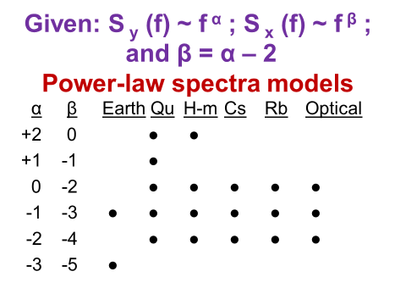
Figure 2 Matrix showing the usefulness of power-law, spectral-density models for Earth = noise in the earth’s rotation rate (after removing all systematics), in Qu = quartz-crystal oscillators, H-m = hydrogen masers, Cs = cesium-beam and cesium-fountain frequency standards, Rb = rubidium-gas-cell frequency standards, and in the new and most stable atomic clocks using frequencies in the optical region of the electromagnetic spectrum.
As one can see in the next figure, the visual appearance of these power-law spectra are very different, and the eye, in some sense, can be a good spectrum analyzer. One of the many reasons why in data analysis one should always visually look at the data is that the brain is an amazing and miraculous processor – a great gift from God.
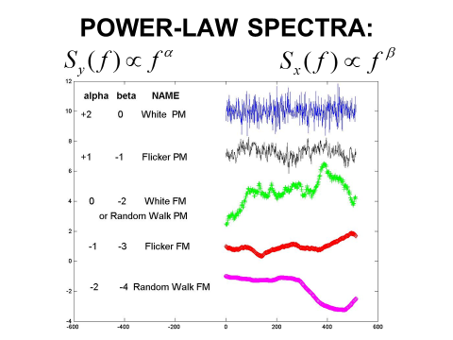
Figure 3. Illustration of visual difference for different power-law, spectral-density models
Using Lighthill’s book, we can transform these spectra to the time-domain. In doing so we obtain figure 4.
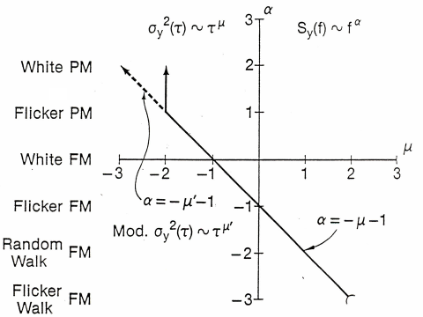
Figure 4. We have α as the ordinate and 𝝁 as the abscissa, where 𝝁 is the exponent on 𝝉 showing the time-domain dependence, and where AVAR = 𝜎_{y}²(𝝉) and MVAR = mod. 𝜎_{y}²(𝝉). We have an elegant Fourier transform relationship in the simple equation α = -𝝁 – 1; we jokingly call it the super-fast Fourier transform, because the AVAR can be computed very quickly from an equally spaced set of data.
Since${ σ}_{y}^{2}\left(τ\right) \sim τ^{μ}$, by plotting log 𝜎_{y}(𝝉) versus log 𝝉, the slope will be 𝝁/2; hence, we can ascertain both the kind of noise as well as its level from such a plot. This sigma-tau plotting technique has been used literally thousands of times to great advantage – giving a quick “super-fast Fourier transform” of the data.
In Figure 4, we notice an ambiguity problem for AVAR at 𝝁 = -2. The simple equation no longer applies, and we cannot tell the difference in the time-domain between white-noise phase or time modulation (PM) and flicker-noise PM. This problem was a significant limitation in clock characterization for the time and frequency community for 16 years after AVAR was developed. Even though there was ambiguity in the 𝝉 dependence in this region, we knew that it could be resolved because there remained a measurement bandwidth sensitivity. Since it was inconvenient to modulate the measurement system bandwidth, this approach never became useful. But in 1981 we discovered a way to modulate the bandwidth in the software, and this was the breakthrough we needed. This gave birth to MVAR, and the concept is illustrated in the following figure.
One can think of it in the following way. There is always a finite measurement system bandwidth. We call it the hardware bandwidth, f_{h}. Let 𝝉_{h} = 1/f_{h}. Then every time we take a phase or time reading from the data, it inherently has a 𝝉_{h} sample-time window. If we average n of these samples, we have increased the sample-time window using software by n, 𝝉_{s} = n𝝉_{h}. Let 𝝉_{s} = 1/f_{s}, then if we increase the number of samples averaged as we increase 𝝉, then one can show that we are decreasing the software bandwidth by 1/n. We were able to show that by modulating the bandwidth in this way we removed the above ambiguity and maintained validity for our simple super-fast Fourier transform equation over all the power-law noise processes of interest; α = - 𝝁’ – 1. There is an unknown proportionality constant between the f_{s} shown below and the f_{s} in the above equations, but fortunately we don’t need to know it to characterize the data.
Figure 5 is an illustration of this software bandwidth modulation for n = 4; in principle, n can take on any integer value from 1 to N/3.
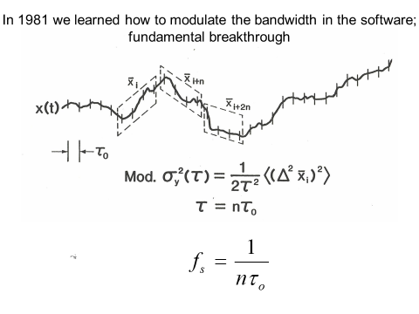
Figure 5. A pictorial of the software-bandwidth modulation technique used in the modified Allan variance to resolve the ambiguity problem at 𝝁 = -2; Hence, this software modulation technique allows us to characterize all of the power-law spectral density models from α = -3 to α = +2. This covers the range of useful noise models for most clocks. Illustrated in this figure is the case for n = 4; n may take on values from 1 to N/3, where N is the total number of data points in the data set with a spacing of 𝝉_{o}.

DATA LENGTH DEPENDENT VARIANCES ARE NOT USEFUL
Going back to 1964, Dr. Barnes had shown that the second and third finite-difference operators on the time variations of a clock gave a convergent statistic in the presence of flicker noise FM. This was the basis of his Ph.D thesis in helping to use a quartz-crystal oscillator ensemble calibrated by the National Bureau of Standards primary cesium-beam-frequency standard to construct a time scale for generating time for NBS and hence for the USA civil sector; the USNO is the official time reference for the USA defense sector.
I had shown in my master’s thesis the divergence of the classical variance or lack thereof for the above power-law noise processes as a function of the number of data points taken. The degree of divergence depends upon both the number of data points in the set as well as upon the kind of noise. In other words, the classical variance was data-length dependent for all of the power-law noise models we were using to characterize clocks except for classical-white noise FM. Hence, the classical variance was deemed not to be useful in characterizing atomic clocks because other than white-noise FM models were needed. This divergence problem seems to exist in all areas of metrology as a result of nature’s natural processes and environmental influences on whatever we are measuring.
I used the two-sample variance as a normalizing factor because I knew from Lighthill and from Barnes’ work that it was convergent and well behaved for all of the interesting power-law spectral density processes that are useful in modeling clocks and measurement systems. The two-sample variance I used may be written as follows:
$σ_{y}^{2}\left(τ\right)= \frac{1}{2}〈{(∆y)}^{2}〉= \frac{1}{2τ^{2}}〈({∆^{2}x)}^{2}〉$,
where the brackets $〈〉 denote the expectation value, or ensemble average,$ and the “2” in the denominator normalizes it to be equal to the classical variance in the case of classical white-noise FM. Don Halford, my Section chief at the time, named this the Allan variance, and the name persists. I don’t mind; jokingly, some ask if I am at variance with the world? When one takes the square root and it becomes the Allan deviation, I cringed a bit, but then as I thought about it, I said to myself, “I am not a deviate!” Deviation is the measure of performance – the change in a clock’s rate – the smaller the better. If I can help these be smaller and smaller, that is good and will help society, and I am all for that.
The ratio of the N-sample variance to the Allan variance as a function of N is shown in the figure 6. Realizing that the N-sample variance is the classical variance for N samples, one sees why it is not useful for characterizing these different kinds of noise, as it is not convergent in many cases and is biased as a function of N in all cases except for classical-white noise. One can turn this dependence to an advantage and use it to characterize the kind of noise using the B1 bias function: B1(N) = σ² (N) / σ²_{y}(τ_{o}).
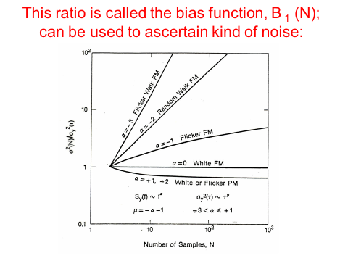
Figure 6. Illustration of the data-length dependence of the classical variance for the different kinds of power-law noise processes used in modeling precision oscillators and atomic clocks.
Following the 1966 IEEE special issue on “Frequency Stability,” the IEEE asked Dr. Barnes to chair a panel of experts and to prepare a special paper on “Characterization of Frequency Stability.” That paper was published in 1971 in which they recommended the spectral density S_{y}(f) and the two-sample variance as the recommended measures of frequency stability. This paper is available on the NIST Time and Frequency Divisions web site: http://tf.boulder.nist.gov/general/pdf/118.pdf Dr. Leonard S. Cutler, who was one of these experts, was the first to write the equation for the time-domain variances in terms of the spectral density, and this is developed in this paper for$〈σ_{y}^{2}(N, T, τ)〉$, equation 23.
As a point of interest, many years ago I was asked to write a paper entitled, “Should the Classical Variance Be Used As a Basic Measure in Standards Metrology?” I researched voltage standards and gauge-blocks, and I found flicker-noise behavior in their long-term performance. A fundamental statement that came out of that research was that if the bias function B₁(N) is not 1 (one) within some reasonable confidence limits, then the classical variance is not a good measure. That advice was not followed by the BIPM standard’s committee even though it has a solid scientific basis. Traditions seem too strong many times even when they are not the best for progress when these flawed traditions continue to be followed.
Note also that the two-sample or Allan variance is without dead-time. In other words, the frequency measurements are sequentially adjacent. For example, the i^{th} frequency deviation taken over an averaging time, 𝝉, may be derived from the time deviations as follows: y_{i} = (x_{i} – x_{i-1})/𝝉. This equation gives us the true average frequency deviation over that interval; it may not be the optimum estimate of frequency. One notices that if the average is taken over the whole data set, then all the intermediate values cancel, and one is left with the true average frequency deviation over the data set: y_{avg} = (x_{N} – x₀)/N𝝉. This is one of the benefits of no-dead-time data. Another is that for classical white-noise FM, as has been found to be the fundamental performance limitation in most atomic clocks, then $σ_{y}^{2}\left(τ\right)$ is an optimum-variance estimator of the change of frequency over the averaging time, 𝝉, and is equal to the classical variance for$σ_{y}^{2}\left(τ_{o}\right)$ – the minimum data-spacing variance.
Dr. Barnes has also shown that $σ_{y}^{2}\left(τ\right)$ is an unbiased estimator for the level of the power-law noise process of interest in modeling atomic clocks and that it is Chi-squared distributed. The value of 𝝉 in the software analysis can take on values for all 𝝉 = n 𝝉_{o} for n = 1 to N/2. The confidence of the estimate is best at 𝝉 = 𝝉 _{o} decreasing to 𝝉 = N/2, where there is only one-degree of freedom for the confidence of the estimate and the Chi-squared-distribution function has a most probable value of zero for one degree of freedom. Even though it is unbiased, the probability of small values is significant. In a $σ_{y}^{2}\left(τ\right) versus$ 𝝉 plot, one often observes too-low of values for $σ_{y}^{2}\left(τ\right)$ as the value of 𝝉 approaches half the data length; then the degrees of freedom are too small for a good confidence on the estimate. David A. Howe and his group at NIST have addressed this problem and have come up with some elegant solutions by adding degrees of freedom to the long-term data; that work is still in progress and is extremely useful (See Howe’s publications on the NIST web site).
In other areas of metrology, one needs to pay attention to this dead-time issue if the noise is not white (random and uncorrelated). As shown in my thesis, the dead-time has an impact on the resulting variance if the noise is not white. The dead-time problem was studied and subsequent papers written. The following link in Chapter 8 of Monograph 140 covers this issue for both the N dependence and dead-time with the bias functions B₁ and B₂, respectively: http://tf.boulder.nist.gov/general/pdf/771.pdf Later, I will show this need not be a significant problem in general metrology applications; it seems to be a unique problem in time and frequency.

THE TIME VARIANCE
In the later part of the 1980s the telecom industry in the United States came to me and asked if I could help them with a metric for characterizing telecommunication networks. I asked Dr. Marc Weiss, who was in my group at NIST at the time, to help me with this project. It was a fascinating work, as we analyzed a lot of their data to find the best metric. Out of this work we developed the time variance, TVAR. It is defined as follows: TVAR = 𝝉² MVAR/3. The “3” in the denominator normalizes it to be equal to the classical variance in the case of classical white-noise PM. Like as for AVAR for FM, one can show that for white-noise PM, TVAR is an optimum estimator of change in the phase or time residuals in a variance sense.
The work in the United States caught on and these three variances became international IEEE time-domain measurement standards in 1988. Interestingly, in their application we see that these three variances have three general regions of applicability:
- AVAR for characterizing the performance of frequency standards and clocks
- MVAR for characterizing the performance of time and frequency distribution systems
- TVAR for characterizing the timing errors in telecommunication networks
Conveniently, TDEV (the square-root of TVAR) has no dead-time issues and has become a standard metric in the international telecommunications industry. All three have application capability in many other areas of metrology. Navigation system errors and gyro errors are some examples. If you search Google for “Allan variance,” you will find about 50,000 hits.

EQUATIONS AND THEIR TRANSFORMS
The equations for computing AVAR, MVAR, and TVAR from the time-deviations and for N data points are respectively:
$$mod.σ_{y}^{2}(τ)= \frac{1}{2τ^{2}n^{2}(N-3n+1)}\sum_{j=1}^{N-3n+1}{{\left(\sum_{i=j}^{n+j-1}{(x_{i+2m}}-2x_{i+n}+x_{i})\right)}^{2}}$$
$σ_{x}^{2}(τ)= = \frac{1}{6n^{2}(N-3n+1)}\sum_{j=1}^{N-3n+1}{{\left(\sum_{i=j}^{n+j-1}{(x_{i+2m}}-2x_{i+n}+x_{i})\right)}^{2}}$,
where the x_{i} are the time deviation data separated by a time interval, 𝝉_{o}, and 𝝉 = n𝝉_{o}.
For MVAR and TVAR, the computation involves a double sum. One may think that this could cause the computation time to increase as N², but one can employ some computation tricks, such as sample drop-add averaging, to make it linear. Otherwise this could be a problem for large data sets. Such tricks have been successfully implemented and the software references cited later include these computation techniques.
The following equations show how the three time-domain variances may be derived from frequency-domain information. One cannot do the reverse – derive the spectral densities from time-domain analysis. When possible, it is often very useful to analyze the data in both the frequency and time-domains. Below we see the frequency-domain view of these variances.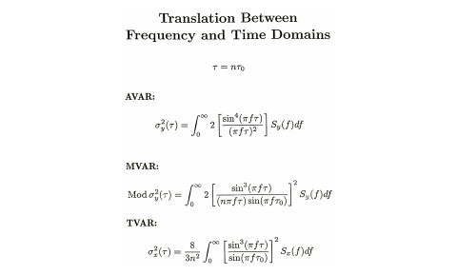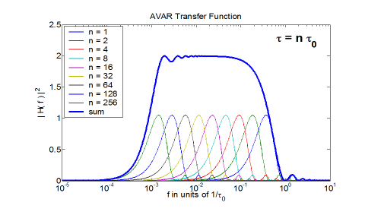 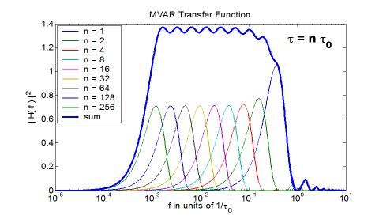
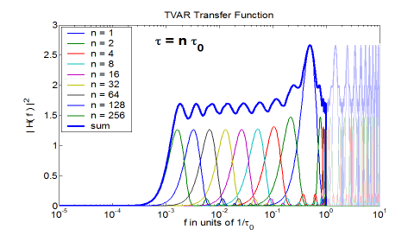
Figure 7 a, b, c, and d. Figure 7a shows the three time-domain equations as derived from spectral densities. Figures b, c, and d show the effective Fourier windows using the transfer functions of each of these three variances for n = 1, 2, 4, 8, 16, 32, 64, 128, and 256.
Three years ago, I was asked to write a paper on “Conversion of Frequency Stability Measures from the Time-domain to the Frequency-domain, vice-versa and Power-law Spectral Densities.” This paper is available on our web site, and has a lot more detail about these conversion processes: http://www.allanstime.com/Publications/DWA/Conversion_from_Allan_variance_to_Spectral_Densities.pdf The conversion relationships are shown in the following table for the five noise types:
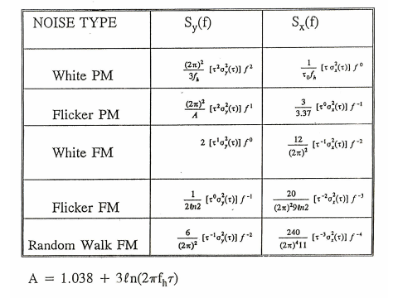
ESTIMATION, SMOOTHING, AND PREDICTION
- ESTIMATION AND SMOOTHING
Box and Jenkins in their book, Time Series Analysis, using the ARIMA process, do a great work on how to estimate and smooth for various kinds of random processes. I will not review their paramount work here.
There is a simple, powerful and useful statistical theorem that I will use for estimation, smoothing, and prediction. It is that the optimum estimate of the mean of a process with a white-noise spectrum is the simple mean. As examples, if we have white-noise PM then the optimum estimate of the phase or the time is the simple mean of the independent phase or time residual readings added to the systmatics.
If we have white-noise FM, then the optimum estimate of the frequency is the simple mean of the independent frequency readings, which is equivalent to the last time readin minus the first time reading divided by the data length, if there is no dead-time between the frequency measurements. As we have shown before, the true average frequency is given by: y_{avg} = (x_{N} – x₀)/N𝝉.
- PREDICTION
Using the above theorem for optimum prediction, if we take the current time as “t,” and we wish to predict ahead an interval 𝝉, then the optimum time prediction, for a clock have white-noise FM and an average offset frequency y_{avg} given by the above equation, is given by: $\hat{x}\left(t+ τ\right)= x_{N}+ τ y_{avg}$. A simple pictorial for the optimum time prediction using this theorem for the five different noise processes is shown in the next figure; for white-noise FM, the y_{avg} is assumed to be zero.
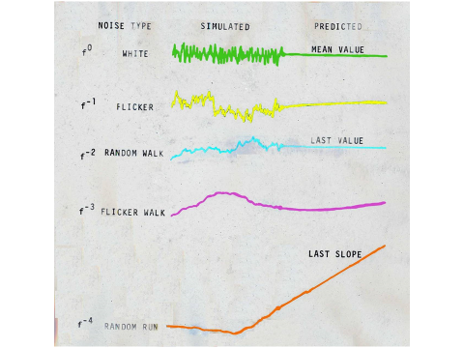
Figure 8. A pictorial illustrating optimum prediction for the five different power-law noise processes used in modeling the time deviations in precision clocks. These prediction algorithms have general appication.
The even-powered exponents are directly amenable to this theorem, but the flicker-noise (odd exponents) are more complicated. However, there is a simple prediction algorithm for flicker FM using what we call the second difference predictor. It is very close to optimum and is simple. If you desire to predict 𝝉 into the future then this prediction can be obtained by the following equation: $\hat{x}(t+$𝝉) = 2 x(t) – x(t – 𝝉), where t is the current time. I have seen this equation used on the stock market, which is often flicker-like in its performance.
Knowing the stability, 𝜎_{y}(𝝉), of a clock allows us to calculate its time predictability capability. As an approximate rule of thumb, the predictability is given by 𝝉 𝜎_{y}(𝝉), Using this equation the next figure shows the time predictability of a variety of timing devices that have been used over human history.

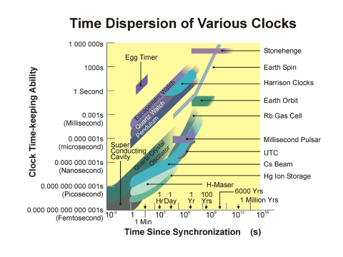
Figure 9. This chart was made back in 1997. If we were to include the ytterbium clock on this graph, it would be represented by a 𝝉^{+1/2} line crossing through 40 femtoseconds at seven hours; or it would be about 100 times better than the best clocks shown here.
A similar plot could be made for the navigation community showing the position dispersion rate for various navigation devices. This may be a useful tool to see which technologies could be brought together in combination to make a significant improvement in both the short-term and long-term performance.

SYSTEMATICS
A good model for time deviations in a clock is: x(t) = x_{o} + y_{o} t + ½ D t² + 𝝴(t), where x_{o} and y_{o} are, respectively, the synchronization error and syntonization error at t = 0, D is the frequency drift, and 𝝴(t) represents the remaining random errors on top of the first three systematic error terms. It is good to subtract the systematics from the data so that the random effects can be viewed visually and then analyzed with better insights. Much can often be learned by this approach. If frequency drift is present in a clock, and it usually is, then it affects AVAR, MVAR, and TVAR in the following way: $σ_{y}\left(τ\right)=mod. σ_{y}\left(τ\right)=Dτ/\sqrt{2 }and σ_{x}\left(τ\right)=Dτ^{2}/\sqrt{6}$ .
An example of the effect of frequency drift on an ADEV plot is shown in the next figure:

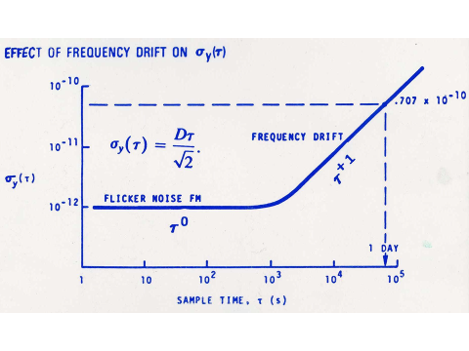
Figure 10. Illustration of the effects of frequency drift on an ADEV plot.
If there is frequency drift, the values of 𝜎_{y}(𝝉), in that region where the drift is affecting the plot, will lie tightly on the 𝝉⁺¹ line. If there is random noise present then the values will not fit tightly to this line.
If there is a frequency modulation, f_{m}, present in the data then it also has a systematic effect on the analysis in the following way for ADEV: $σ_{y}\left(τ\right)= \frac{x_{pp}}{τ} \sin^{2}\left(πf_{m}τ\right)$, where x_{pp} is the peak-to-peak amplitude of the modulation. The following figure shows the effect on an ADEV plot:
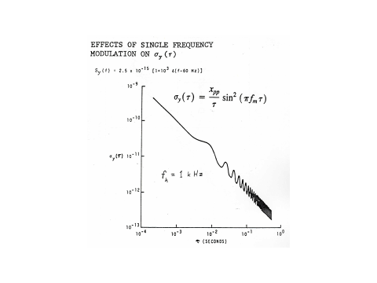
Figure 11. ADEV with frequency modulation, f_{m}, present on the data
Both MVAR and TVAR are affected as well. A plot of the effect on TDEV is shown in the next figure.
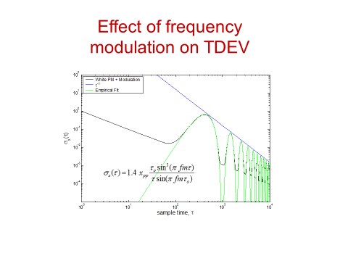
Figure 12. The effect of frequency modulation on a TDEV plot when that modulation is on top of the signal and noise. The white-noise PM causes the 𝝉^{-1/2} behavior in the plot. Notice the modulation averages down as 𝝉⁻¹. The equation fitting the effects of the modulation is empirical.
At 𝝉 = n 1/f_{m}. the effect of the modulation is aliased away, where n is any positive integer. Recognizing this null effect allows these three variances to be used as low-frequency spectrum analysis techniques. We will find this effect very useful in the EXAMPLES section of the paper, which is next.

EXAMPLES AND APPLICATION OPPORTUNITIES OF THESE VARIANCES
- CLOCKS OF THE 1960s AND 70s
In the following figure we have a sigma-tau plot of the frequency instabilities between a precision free-running, quartz-crystal oscillator and a commercial cesium-beam atomic clock. One sees for sample times, 𝝉, shorter than one second a 𝝉⁻¹ behavior do to the measurement noise. This plot was made before MVEV was developed, so we are not sure of the noise type because of the ambiguity problem with ADEV for this slope. The rise in the value of 𝜎_{y}(𝝉) as the sample or averaging time approaches 10 seconds is due to the attack time of the cesium-beam locking its quartz-crystal-slave-oscillator to the cesium resonance. Over the next decade we see a 𝝉^{-1/2} behavior; or 𝝁 = -1 which means α = 0 from our simple “super-fast-Fourier” transform relationship, and this is classical white-noise being measured for this cesium-beam atomic clock. For the longest averaging times we see a 𝝉⁰ behavior, which then corresponds to α = -1, and this is due to the flicker-noise FM of the precision, quartz-crystal oscillator. Even with the ADEV ambiguity problem, we were delighted in the 1960s and 70s to be able to characterize so easily the noise type and level of the clocks then being used for timekeeping for the USA.
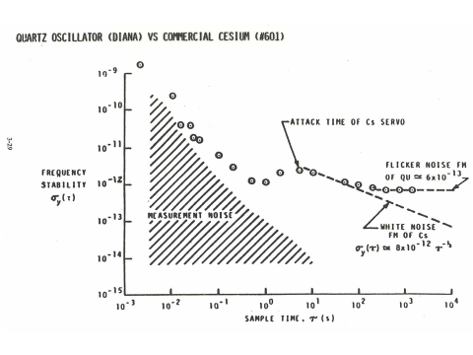
Figure 13. An ADEV plot for a precision, quartz-crystal oscillator versus a commercial cesium-beam atomic clock.
In 1968, we had a very interesting clock comparison at NBS in Boulder, Colorado. Bob Vessot brought his hydrogen maser from Smithsonian Astronomical Observatory, Boston, Massachusetts. Harry Peters brought his hydrogen maser from NASA Goddard, Beltsville, Maryland. Len Cutler brought his Hewlett Packard cesium-beam, atomic clock from Palo Alto, CA. We had the NBS primary frequency standard and data acquisition systems. This grand-clock-comparison effort resulted in an interesting 12 author paper. [http://tf.boulder.nist.gov/general/pdf/172.pdf]
It was my responsibility at that time to provide the NBS reference time-scale for comparing all of these clocks. Up to this point, Jim’s algorithm had been generating time for NBS and for the civil-sector of the USA. With Jim’s ever-present help, and I felt help from above, I wrote a new time-scale algorithm, AT-1. With several refinements by Tom Parker and Judah Levine since that time, that algorithm is still generating time for the nation today. This time-scale algorithm was a major application of the "Allan variance" and generated a near real-time software clock with the following optimization features:
Its software-clock output can be shown to be better than the best clock providing input;
Even the worst clock enhances the output;
If a clock misbehaves, it is rejected and not used – avoiding unnecessary perturbations;
Each clock gets an optimum weighting factor for inclusion in the time computation;
The weights are adaptive so that if a clock improves over time, its weight increases and vice versa;
The optimum time of each clock as well as the optimum estimate of the frequency of each clock are estimated at each measurement cycle;
Both the short-term as well as the long-term stability of the software ensemble output are optimized;
It is able to deal with white-noise FM, flicker-noise FM, and random-walk FM, which are the kinds of noise processes that well model the atomic clocks being used;
Originally, I used a PDP-8 computer and had eight clocks in the ensemble; AT-1 had 94 lines of code and provided error messages. I had to use some variables three times to not exceed the available logic limit.
It is interesting to watch this algorithm’s performance, because it is almost as if it is alive as it breathes with each clock’s behavior. AT-1 has been generating the official time for the USA for over 46 years.
- NEW OPTICAL CLOCK STABILITIES USING TOTAL ADEV
As we look at some of the exciting new optical clocks, the following ADEV plot is from data taken at NIST in Boulder, Colorado comparing two ytterbium optical lattice clocks in 2013. This plot utilizes the “Total ADEV” approach developed by David A. Howe and his group, which gives optimum confidence on the long-term stability estimates for ADEV. Long-term data are extremely valuable, so this “Total ADEV” technique adds greatly to the information one is able to learn from the data.
Here we see the best stability ever observed to that date of 𝜎_{y}(𝝉 = 25,000 seconds) = 1.6 x 10⁻¹⁸. This is like an error of 50 ps in a year. A picosecond is a million-millioneth of a second (10⁻¹² s); 50 ps is the time it takes light to travel 1.5 cm. This is 20 times better than the nanosecond accuracy that GPS needs and they have to upload their GPS corrections at least once a day. In this plot we see the nearly ideal atomic-clock white-noise FM (𝝉^{-1/2}) behavior over about four decades of averaging time at a remarkable level of 3.2 x 10⁻¹⁶ at 1 second.
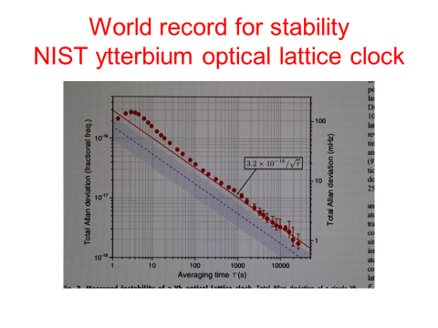
Figure 14. Comparison of two ytterbium optical-lattice atomic clocks operating at 518 295 836 591 600 Hz

MILLISECOND PULSAR TIMING USING MDEV
Going back to 1982, the first millisecond pulsar was discovered by Don Backer, Shri Kulkarni, Carl Heiles, Michael Davis, and Miller Goss. Its name PSR B1937+21 is derived from the word "pulsar" and the declination and right ascension at which it is located, with the "B" indicating that the coordinates are for the 1950.0 epoch. This pulsar had the best astronomical timing performace of anything ever observed. I read their paper and was intrigued. I could see some ways we could help them, so I made contact with Dr. Michael Davis, who was the scientist in charge at the Aericebo Observatory where the data were being taken. Mike invited me down, and in 1984 I installed a GPS common-view receiver to tie their clock, which was making the pulsar measurements, to the world’s best atomic clocks.
One can see in the next figure, the very complicated system for this millisecond pulsar measurement and the nominal behavior in each link of the measurement system chain.
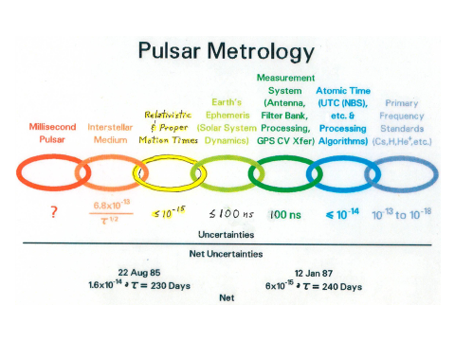
Figure 15. Measurement system for the millisecond pulsar. Note the improvement of nearly a factor of three in the stability measurements from 1985 to 1987 indicated at the bottom of the figure due to the help we were able to give them.
The next figure is an excellent example of the advantages of the modified Allan variance. As I studied the data, I was able to observe random-walk (f⁻² spectrum) in the delay between two different observation frequencies for the pulsar. They had assumed that the electron content along the path was constant. This result showed that it was not and when the 1/f² ion content correction was applied the random-walk effect was suppressed leaving white-noise PM residuals as is shown in the next figure using MDEV to show this benefit.
Over the next several years, they did a 25-million dollar upgrade on the Aericebo telescope to bring about several major improvements and hoping to move the measurement noise down to the indicated 100 ns level.
In about 1990, I shared the following frequency stability plot at a UC Berkley, California, millisecond pulsar workshop. As these new fast spinning pulsars were thought to be competitive with atomic clocks, there is a very fundamental message in this plot. Even if they achieve the 100 ns white-noise PM measurement noise level with their upgrade, the data need to be averaged for about 200 years to reach a stability level of 10⁻¹⁸, which is about where the best clocks are now. In other words, you would get one data point every 200 years at the 10⁻¹⁸ level – clearly not a competitive clock. I had no comments from my expert millisecond pulsar colleagues in the audience! One may further note that the ytterbium stability has, as of two years ago, surpassed by a factor of three that shown in the figure for the best anticipated performance of the cooled single Hg ion.
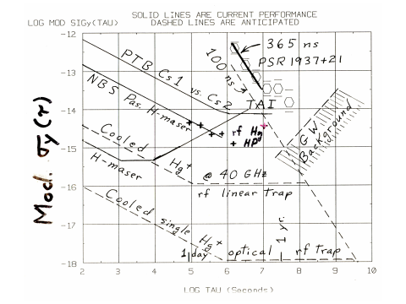
Figure 16. The PTB is the primary frequency standards laboratory for Germany. “Pas” stands for passive hydrogen maser. H-maser is for an active hydrogen maser. For shorter than 100-second averaging times, active hydrogen masers often exhibit white-noise PM, which is a 𝝉 ^{-3/2} slope like the slope of the measurement noise of the pulsar. PSR 1937+21 is located about 1/7th of the way across our galaxy, and the hope then was that we might see gravitaional-wave perturbations in the path indicated by “GW Background.”
- OPPORTUNITY FOR IMPROVING GPS ACCURACY
The GPS satellites (SVs) are at an orbit radius of about 4.2 earth radii. This distance creates a significant geometry problem for determining the vertical distance of the satellites from the center of the earth because the tracking stations’ vectors are too close to parallel. GLONASS solves this problem by using retro-reflectors on the satellite and by doing round-trip-laser ranging from a ground station of known position to each of the satellites. This they can do to about 5-cm accuracy, which is about 12 times better than GPS.
Kepler’s third-law has built into it the needed orthonality to solve this vertical-distance problem: $T^{2}= \frac{4π^{2}}{GM} r^{3}$, where T is the orbit period, G is the universal gravitaional constant, M is the mass of the earth, and r is the radius from the center of the earth to the satellite. Since the orbit is tangential to the radius vector, if we can determine the point of closest approach to a tracking station of known coordinates, then we have the orthogonal information we need to determine the radius vector. The Doppler shift of an SV’s clock will go to zero at its point of closest approach with respect to its tracking station. This zero-Doppler shift gives us a precise marker in its orbit period, T, with an uncertainty δT. From the above equation, we can derive the uncertainty in the radius vector: $δr= \frac{2}{3} r \frac{δT}{T}$. With current high-performance atomic clocks and using MDEV to assure that the residuals are white-noise PM, so that all the systematics have been properly removed, then our calculations indicate that δr can be made to be less than a centimeter. The value of δT can be made very small because with white-noise PM being the limiting measurement noise, its value decreases as the data-length to the minus 3/2s power for the viewing-time of the satellite’s pass.
There are some important contingencies associated with making this equation work properly. Professor Neil Ashby, who did the relativity equations for GPS, and I worked on this in the 1990s and got some excellent results. Clocks have gotten significantly better since then and the requirement for a zero-g environment as was done for Gravity Probe-B is now more readily available. There are some other contingencies, but the advantages are enormous; being an all-weather system is one. One of the biggest diadvantages is that this approach is a major change in system architecture, but these changes could be done in a meaningful step-wise process.
I felt that this-high accuracy technique was far enough along that I sent a letter to the GPS Headquarters folks for their consideration. I describe this some in Chapter 20 of my book and the details may be found in Appendix K of the book’s web site, www.ItsAboutTimeBook.com .
- NEW UNIFIED FIELD THEORY RESULTS VALIDATED USING ADEV
Starting in 1999, we were working to understand a new concept in relationship to the UFT. This concept is explained in papers on our web site: www.AllansTIME.com/UFT_private and in Chapter 21 of the book. The book has exciting new information that has never been published before. The concept is that what we call diallel-field lines can carry all four of the force fields plus much more and connect everything to everything. The book by Lynne McTaggart, The Field, describes many experiments consistent with this new UFT.
We first did experiments to show the existence of these diallel-field-lines, and then that they had quantum states. Whereas the quantum states in atoms or molecules are generally thought of as being spherical or elliptical, they are nominally cylindrical in the diallel-field structure. In the Fall of 2000 we observed for the first time emissions from these diallel-field-lines. This and some of the other experiments were performed in the laser physics lab at BYU. They kindly let me use it as an alumnus. All these experiements are described in Chapter 21 of my book. We have done seven experiments to date validating this new UFT diallel-field-line theory.
The following figure illustrates the diallel-field-line coupling of the planets to the sun and their effect on the sun-spot activity. I used 100 years of sunspot data and I analyzed it using ADEV as shown in the following figure. As predicted by this new UFT, we were delighted to find the periods of all the major planets present in the data except for Uranus, where our data length was insufficient. I also used the masses, the magnetic fields, and the planet’s orientations in space to see if I could nominally duplicate the sun-spot activity over the last 100 years. I had about an 80% correlation coefficient fit to the data. There is still a lot to be learned. We feel like infants exploring the biggest forest in the world.

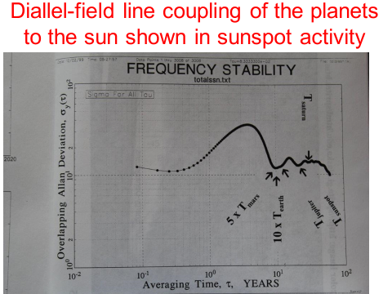
Figure 17. ADEV plot of 100 years of sun-spot data showing the periods of all the major planets except for Uranus, where our data lenth was too short to resolve its period.
- SYNCHRONIZATION AND SYNTONIZATION OF SOULS
I saved the best for last in the following and last example and which also may be called “How to resonate our souls with God.” We will see how synchronizing and syntonizing our souls with God has the greatly desired effect of ONEness (resonance) with Him. Whereas synchronization means same time, syntonization means same frequency or same tone. Two clocks can be syntonized and have very different times; they could be an hour apart in their time readings while running at the same rate. If syntonized but not sysnchronized, then the time-difference remains constant, and they are out of sync. Because the time error of a clock is the integral of the frequency error, sychronization guantees syntonization. We will see this concept being very important as we develop how to resonate our souls with God.
I discuss the fascinating MASER and LASER action – invented by Nobel Prize winner Charles Townes, et. al. -- in Chapter 20 of my book: www.ItsAboutTimeBook.com. Maser and laser are acronyms meaning Microwave or Light Amplication by Stimulated Emmission of Radiation. In a hydrogen maser, when a hydrogen atom enters the resonant cavity of the maser in an excited-quantum-clock-transition-energy state, it is stimulated to give off its clock-transition photon in phase (synchronized and syntonized) with all the emissions of all the other atoms, which have already entered the cavity. The photons of all the atoms are in resonance with each other. Because of this resonance phenomena, the time deviation TDEV time-tability plot improves as the square-root of the averaging time, 𝝉 ^{-1/2}. This gives hydrogen masers their excellent short-term frequency and time stability. But, as explained in Chapter 20, for significant reasons, this ideal resonance phenomena does not persist. Analagously, these reasons will be important later in this example.
There is an instructive illustration of resonance demonstrated in the following one-minute and 25-second you-tube video: https://www.youtube.com/watch?v=sUOnaHTXf18. This Russian experimenter shows five metronoms coming into resonance as they are coupled through a sounding-board. Notice, he first shows that they do not resonate until the coupling-sounding-board is free to operate among the metronoms. If a TDEV time stability plot were made of the time-differences of the metronoms in this Russian’s experiement, the stability would improve like the masers after resonance was achieved, but not before. This resonance phenomena was first observed by the famous inventor of the pendulum clock, Christiaan Huygens, back in the 1600s.
Being a devout Christian and a scientist, I have pondered the apparent conflicts and lack of resonance between science and religion over my 78 years on this planet. A survey taken at the end of the last century showed that 93% of America’s major scientists were agnostic or athiestic in their beliefs; they believed that good science excludes God and things spiritual. In my book, It’s About Time, the opposite message is developed. Truth does not contradict truth. True science and true religion will harmonize, and this is the main message of the book, www.ItsAboutTimeBook.com. I show that this harmony is brought about by using an expanded version of the scientific method (Chapter 1), which includes God and experiemental data consistent with this expanded version as developed in chapters 2 and 3.
The moral decline in America and in much of the world is in large measure a result of the encroachment of secularism, humanism, and materialism on society, which exclude God and things spiritual. Using this expanded scientific method with some exciting new data, the book is a counter-attack to this encroachment. This counter-attack is accomplished by showing that living the law of love as taught by Christ is the answer to all of our problems and can and will bring about the harmony, oneness and goodness we all desire in an ideal society. This ideal is achieved when our actions resonate with the teachings of Christ and we are living the law of love. Our souls become synchronized and syntonized with God.
As a scientific example of how this ideal society can come to be, consider the following. Emeritus Professor of Philosophy, Chauncey Riddle, develops in his book, Think Independently, the very important concept that because of agency (free choice), if there are seven billion people on this planet, then there are seven billion different “world views.” The law of love moves us to respect that each is entitled to his/her own world view.
Then we have the summation and powerful High Priest’s prayer in the Bible in the gospel of John Chapter 17 just before He (the Christ) worked out the infinite and all encompasing atonement for all of Heavenly Father’s children. The core message of this prayer, which is the core message of the Christian faith, is that as we come to believe in and live Christ’s teachings, we will become one with Christ (in harmony and resonating with eternal truth) even as Christ and the Father are one. And Christ begins this profound prayer with the identity that eternal life is to know the Father and the Son – wherein is a fullness of joy and which is the main purpose of our mortal journey.
This oneness seems a contradiction to Professor Riddle’s thesis that each of us has a different “world view,” but I will show with a scientific illustration that the gospel of Jesus Christ is the “good news.” For me it is the best news, because living Christ’s gospel brings about this most desired oneness and great harmony we desire in society.
This scientific illustration is a fun one for me, because it relates to my life-long work with clocks, which I have been working with for 55 years! Suppose each of us is like a clock. One can show that if measured with enough precision, every clock disagrees with every other clock, except at some moment when two clock readings may crossover. This disagreement comes as a result of chaotic noise perturbing each clock’s time and rate – each clock has a different frequency (clock rate) and time. This is like each person having a different “world-view.” And this is like the masers being perturbed by other influences and their performance degraded from the ideal.
We were all born innocent, and our clocks were all in synchronism with God at our birth. Then as our mortal clocks started ticking when we began our journey in life, we became asynchronous due to our challenges in life and our world views diverged from the perfect world view of God. As developed in Chapter 2 of It’s About Time, these challenges are for our growth if we keep our focus on God. Opposition is an essential part of Heavenly Father’s perfect plan of happiness, which seems to be a big contradiction, but you will see that opposition preserves our agency – giving us the right to choose between good and evil. Opposition and life’s challenges give us the opportunity to grow and to have a deeper appreciation of the value of the eternal truths of God, which appreciation we could not gain otherwise. Understanding and living harmoniously with these eternal truths of God brings science and religion into perfect harmony and brings us a fullness of joy in eternal life, as well as peace, love, and joy in this life.
Because of God’s infinite love for us, He gave us His Only Begotten Son that whosoever believes in Him and lives His teachings shall have eternal life (John 3:16). Christ also gave us our conscience to “light” our way that we may know good from evil (John 1:9). At each decision point in life, we choose. As we choose the good, we synchronize our souls with the will of God; otherwise, we become more asynchronous and are estranged from God. Well did the Apostle James say, “Therefore to him that knoweth to do good, and doeth it not, to him it is sin.” (James 4:17) A loving and merciful God has given us the door of repentance made effective through the infinite atonement of Christ that we may resynchronize our souls with God. Also, in God’s love He has angels round-about-us to counter the adversary’s opposition. Taking from Shakespeare’s Othello, from Charles Dickens’ Barnaby Rudge, Chapter 29, which Abraham Lincoln used in his inaugural address, let us choose our “better angels,” who are whispering to us the best path for us. Can we imagine a higher path in life than going about – best using our time and talents – in doing good as we follow the light of Christ?
This is “the still small voice” shared so profoundly in the Bible (1 Kings 19:12). Following this still small voice moves us to the path that aligns with the mission we agreed to do during our mortal journey and which will bring honor and glory to our loving Heavenly Father. With Him, in a pre-mortal epoch, we agreed and rejoiced in our opportunity to come to earth. As developed in Chapter 2 of It’s About Tine, we had a very special interview with our Heavenly Father in which we jointly mapped out our life’s mission that we knew would be for our eternal best good. Because we have free agency, we can choose not to do our mission, but that path will not be the best for us.
As we apply faith in the Lord Jesus Christ in our lives and repentance, which means changing our path direction to align with His will for us, we move our souls’ clock closer to synchronism with Him. One can show mathematically that our frequency (our different world views) will move ever closer into perfect resonance with the Father through the Son as we move to be one with them and their teachings. This is the process of becoming ONE. The following simple equation will allow us to prove this ONEness concept, which equation is derived from an equation developed earlier in the paper, that our lack of resonance with God is given by $y_{avg}= \frac{x_{N}}{Nτ_{avg}}$, where x_{N} represents our last decision point. At that point, did we choose to follow Christ or otherwise? God is ever there to hear our prayer and to know our thoughts and the intents of our hearts, as explained in Chapter 22 of It’s About Time. We can synchronize our thoughts and actions with Him through prayer and pondering, studying or listening to His word. It is exciting to know that in our desires to synchronize our will to His that each of us has a unique mission, given our different times on earth and our different talents. In His infinite wisdom, He knows our uniqueness and will customize the inspiration given to each of us for our eternal best good. His will is to have each of us return to Him and receive a fullness of joy, but know that He will not force us; such force would violate our free agency, and He will never do that. As we treasure up His word and hearken to it, on our N^{th} occasion to do so, we move x_{N} closer to synchronism as we align our will to His. If we choose otherwise, we move our clock further away from the “correct time.”
Like the sounding-board for the metronomes needs to be “free” to facilitate resonance among the metronomes, so we need to get out of the noise of the world and find the freedom in communion with God that will open our minds and hearts to the still small voice. His loving arms are stretched out continually to all of us in His infinite capacity to do so that we may find resonance with Him through faith in Christ and repentance from sin.
The denominator in the above equation, N 𝝉 _{avg}, is the time we have ticked off on earth. N is the number of decisions we have made, and 𝝉_{avg} is the average time between decisions. The denominator ever grows larger and the numerator can be made smaller and smaller as we synchronize our wills to the will of the Father, as the Son did perfectly. One can show that this equation converges to perfect resonance; we grow into an oneness with God and are guaranteed eternal life in that process. Our world views become aligned with His perfect world view. His promise is, “Ye shall know the truth, and the truth shall make you free.” (John 8:32).
In that unity we become free of sin as individuals, and free from bondage as a society. We become one with God in that ideal society motivated by pure love, and each of our time and talents is thus utilized fully to the betterment of that society in time and in eternity. We model our society after the harmony of the Godhead. The Father, Son, and Holy Ghost each have different missions within the Godhead, but they are one – motivated by pure and perfect love, They move the cause of Truth forward throughout the universe. Following this perfect model is how, as Jesus has asked us to pray, that Father’s kingdom comes on earth as it is in heaven. Could there be a more exciting message – a society based on the pure love of Christ, which will inherit a fullness of joy?
Please feel free to contact me if you have questions or comments regarding my paper or this example of “How to resonate our souls with God.” For those wishing to chat on-line about the gospel of Jesus Christ you may visit Mormon.org. They have the facility to chat in some 50 different languages.

REFERENCES
There are a very large number of publications about the three variances developed in this paper. I refer you to the NIST Time and Frequency Division publication web site for many of these. And I refer you to the 1988 IEEE Standard 1139-1988: Standard Terminology for Fundamental Frequency and Time Metrology, to the 1990 NIST Technical Note 1337, Characterization of Clocks and Oscillators, to the 1997 ITU HANDBOOK: “Selection and Use of Precise Frequency and Time Systems,” to the 1997 Hewlett Packard Application Note 1289, The Science of Timekeeping, to the 2000-2014 additional variance work at NIST giving additional degrees of freedom and providing efficiency & tighter confidences on the variance estimates – http://tf.nist.gov/general/publications.htm, to the “Handbook of Frequency Stability Analysis,” by W. J. Riley, NIST Special Publication, SP 1065 (2007), also available at www.wriley.com, and to Chapter 20 of my 2014 book www.ItsAboutTimeBook.com ; Appendix J at this link is also the booklet The Science of Timekeeping.

